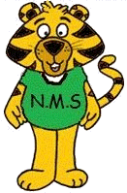
Grade 2
School Supply List

Hello Grade 2 Families!

We want to welcome you and your child to grade ! In the fall we will be collecting a $50 student fee. This can be paid online using School Cash.
In addition to the student fee, we are asking that students bring the following items with them the first day of school.
- Backpack
- Lunch box
- Sneakers (non-marking sneakers for in class and the gym)
- 2 Boxes of Kleenex
- Water Bottle (non-spill)
* All items should be clearly labeled with your child’s name.
We look forward to meeting you in September!
Sincerely,
NMS Teaching Team

